*Welcome To*

**Trinity Lutheran Church**

Lutheran Church—Missouri Synod

*A Stephen Ministry Congregation*

1354 South Otsego Avenue

Gaylord, Michigan 49735

Church Phone: (989) 732-4816

Church Email: secretary@trinitygaylord.com

www.trinitygaylord.com

Office Hours: Monday through Friday 9am – 1pm

**OUR PURPOSE**

…is to **LOVE GOD, LOVE OTHERS, AND SERVE THE WORLD** by worshiping the Lord Jesus, bringing our members into Christ-like maturity, and equipping them through Word and Sacrament for their mission and ministry. We go heart to heart into the world with Jesus, sharing His love, caring for one another, praying, and bringing the lost into a relationship with Christ, by the working of the Holy Spirit.

***June 19, 2022***

***Father’s Day***

*Second Sunday after Pentecost*

*Preacher: Rev. Paul Schneider*

**ABOUT OUR WORSHIP**

**We welcome all who gather here today!** We are blessed to celebrate together the mercy, grace, and love we have from God through the death and resurrection of our Lord Jesus Christ.

**Children:** Families with children are *very* welcome here. Having children in church is important so they can begin to learn about their faith in Jesus, and it’s good for the whole congregation to see. *Please feel comfortable keeping “squirmy”* *kids in the service. This is where they belong, too!*

***Pew Cards: Guests and Members, please fill out the Guest/Member card located on the back of the pew in front of you and pass it to the end of the aisle. If you forget you can put it in the offering plate on your way out.***

**If standing is difficult:** Please feel free to remain seated during any portion of the service. Please let an Elder or Usher know if you need communion in your pew seat.

**About our celebration of Holy Communion:** We celebrate the Lord’s Supper in the confession and glad confidence that, as he says, our Lord gives into our mouths not only bread and wine but his very body and blood to eat and to drink for the forgiveness of sins and to strengthen our union with him and with one another. Our Lord invites to his table those who trust his words, repent of all sin, and set aside any refusal to forgive and love as he forgives and loves us, that they may show forth his death until he comes.

Because those who eat and drink our Lord’s body and blood contrary to that which is stated above do so to their great harm, and also because Holy Communion is a confession of the faith which is confessed at this altar. Anyone who is not yet instructed, in doubt, or who hold a confession differing from that of the Lutheran Church—Missouri Synod, and yet desire to receive the sacrament, are asked first to speak with Pastor. Those not communing are still invited to come forward for a blessing from Pastor, and you may indicate this by crossing your arms over your chest.

TTTTTT

**GREETING**

P Peace be with you.

**C And also with you.**

P Let us pray.

# **T ORDER OF SERVICE T**

*(The liturgy is from Divine Service Setting four LSB pg. 203ff)*

**OPENING HYMN**

**All Hail the Power of Jesus’ Name** *LSB 549 sts. 1–3*

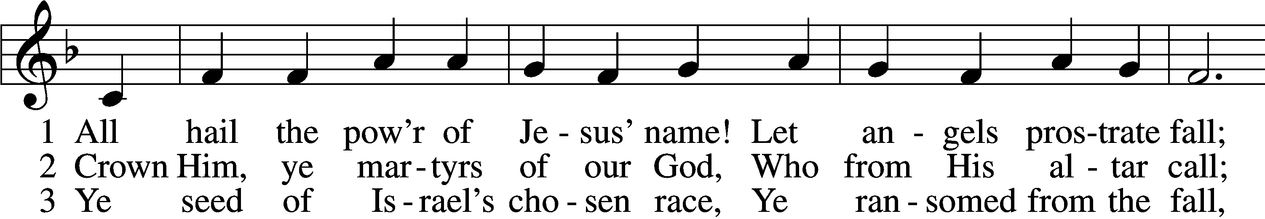

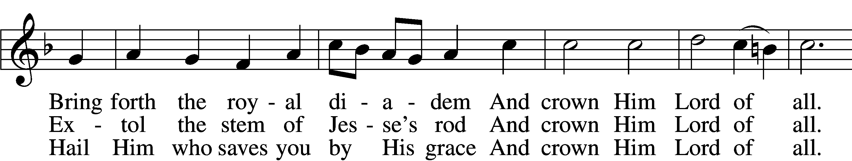

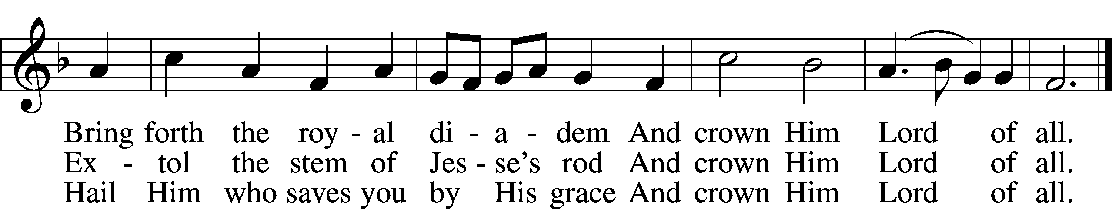

Text: Edward Perronet, 1726–92, alt.

Tune: Oliver Holden, 1765–1844

Text and tune: Public domain

*Please stand as able*

**CONFESSION and ABSOLUTION**

The sign of the cross may be made by all in remembrance of their Baptism.

P In the name of the Father and of the T Son and of the Holy Spirit.

**C**  **Amen.**

P Our help is in the name of the Lord,

C **who made heaven and earth.**

P If You, O Lord, kept a record of sins, O Lord, who could stand?

C **But with You there is forgiveness; therefore, You are feared.**

P Since we are gathered to hear God’s Word, call upon Him in prayer and praise, and receive the body and blood of our Lord Jesus Christ in the fellowship of this altar, let us first consider our unworthiness and confess before God and one another that we have sinned in thought, word, and deed, and that we cannot free ourselves from our sinful condition. Together as His people let us take refuge in the infinite mercy of God, our heavenly Father, seeking His grace for the sake of Christ, and saying: God, be merciful to me, a sinner.

C **Almighty God, have mercy upon us, forgive us our sins, and lead us to everlasting life. Amen.**

P Almighty God, merciful Father, in Holy Baptism You declared us to be Your children and gathered us into Your one, holy Church, in which You daily and richly forgive us our sins and grant us new life through Your Spirit. Be in our midst, enliven our faith, and graciously receive our prayer and praise; through Your Son, Jesus Christ, our Lord.

C **Amen.**

# **SERVICE OF THE WORD**

**KYRIE**  LSB 204

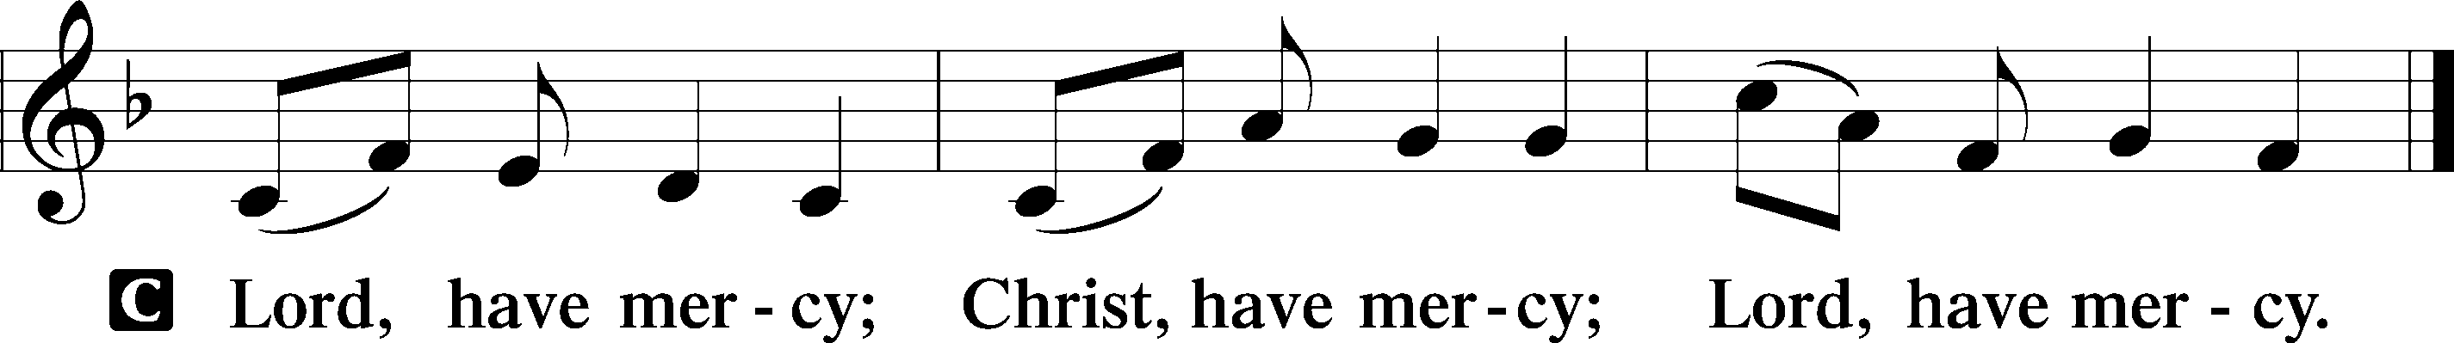

**HYMN OF PRAISE**

**GLORIA IN EXCELSIS** *LSB 204*

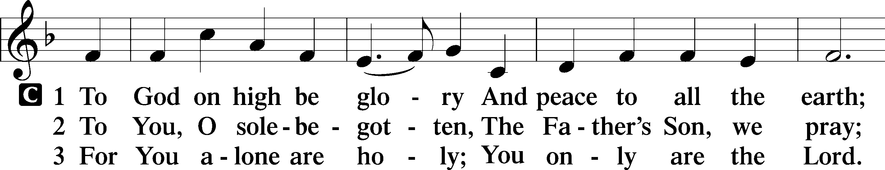

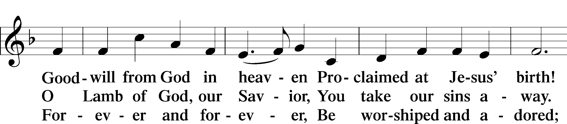

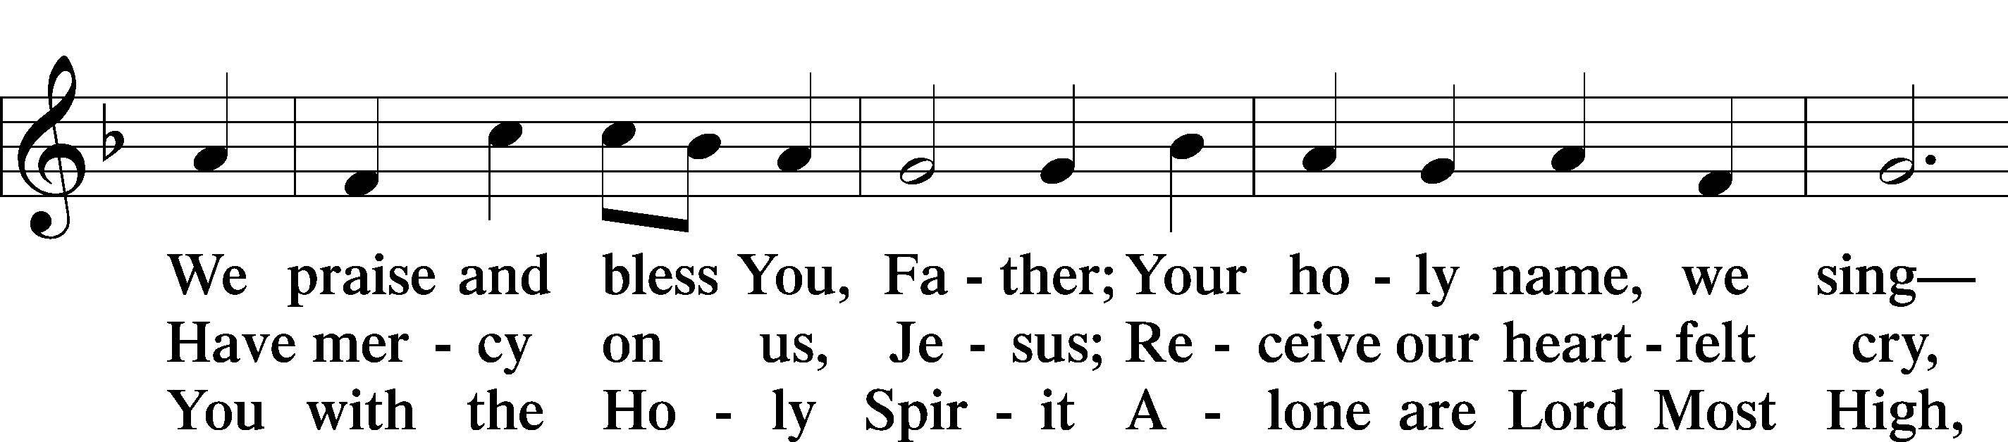

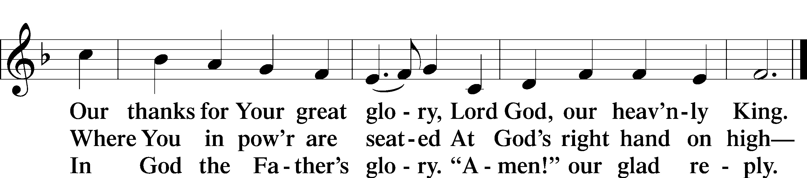

Text: Stephen P. Starke

SALUTATION AND COLLECT OF THE DAY

P The Lord be with you.

C **And also with you.**

P Let us pray.

O God, You have prepared for those who love You such good things as surpass our understanding. Cast out all sins and evil desires from us, and pour into our hearts Your Holy Spirit to guide us into all blessedness; through Jesus Christ, Your Son, our Lord, who lives and reigns with You and the Holy Spirit, one God, now and forever.

C **Amen.**

*Please be seated*

FIRST READING *Isaiah 65:1–9*

1I was ready to be sought by those who did not ask for me;  
 I was ready to be found by those who did not seek me.  
I said, “Here am I, here am I,”  
 to a nation that was not called by my name.  
2I spread out my hands all the day  
 to a rebellious people,  
who walk in a way that is not good,  
 following their own devices;  
3a people who provoke me  
 to my face continually,  
sacrificing in gardens  
 and making offerings on bricks;  
4who sit in tombs,  
 and spend the night in secret places;  
who eat pig’s flesh,  
 and broth of tainted meat is in their vessels;  
5who say, “Keep to yourself,  
 do not come near me, for I am too holy for you.”  
These are a smoke in my nostrils,  
 a fire that burns all the day.  
6Behold, it is written before me:  
 “I will not keep silent, but I will repay;  
I will indeed repay into their bosom  
 7both your iniquities and your fathers’ iniquities together,  
says the Lord;  
because they made offerings on the mountains  
 and insulted me on the hills,  
I will measure into their bosom  
 payment for their former deeds.”

8Thus says the Lord:  
“As the new wine is found in the cluster,  
 and they say, ‘Do not destroy it,  
 for there is a blessing in it,’  
so I will do for my servants’ sake,  
 and not destroy them all.

9I will bring forth offspring from Jacob,  
 and from Judah possessors of my mountains;  
my chosen shall possess it,  
 and my servants shall dwell there.”

P This is the Word of the Lord.

C **Thanks be to God.**

**EPISTLE** *Galatians 3:23—4:7*

23Now before faith came, we were held captive under the law, imprisoned until the coming faith would be revealed. 24So then, the law was our guardian until Christ came, in order that we might be justified by faith. 25But now that faith has come, we are no longer under a guardian, 26for in Christ Jesus you are all sons of God, through faith. 27For as many of you as were baptized into Christ have put on Christ. 28There is neither Jew nor Greek, there is neither slave nor free, there is neither male nor female, for you are all one in Christ Jesus. 29And if you are Christ’s, then you are Abraham’s offspring, heirs according to promise.

1I mean that the heir, as long as he is a child, is no different from a slave, though he is the owner of everything, 2but he is under guardians and managers until the date set by his father. 3In the same way we also, when we were children, were enslaved to the elementary principles of the world. 4But when the fullness of time had come, God sent forth his Son, born of woman, born under the law, 5to redeem those who were under the law, so that we might receive adoption as sons. 6And because you are sons, God has sent the Spirit of his Son into our hearts, crying, “Abba! Father!” 7So you are no longer a slave, but a son, and if a son, then an heir through God.

P This is the Word of the Lord.

C **Thanks be to God.**

*Please stand as able*

**ALLELUIA AND VERSE**

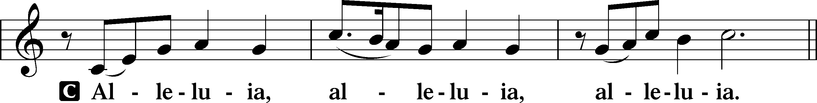

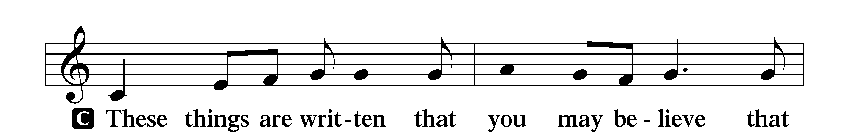

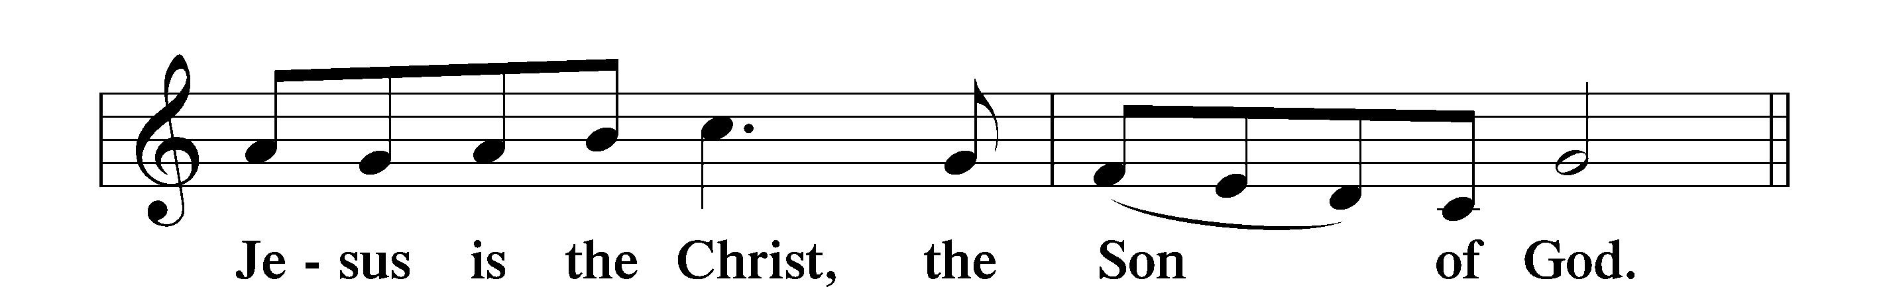

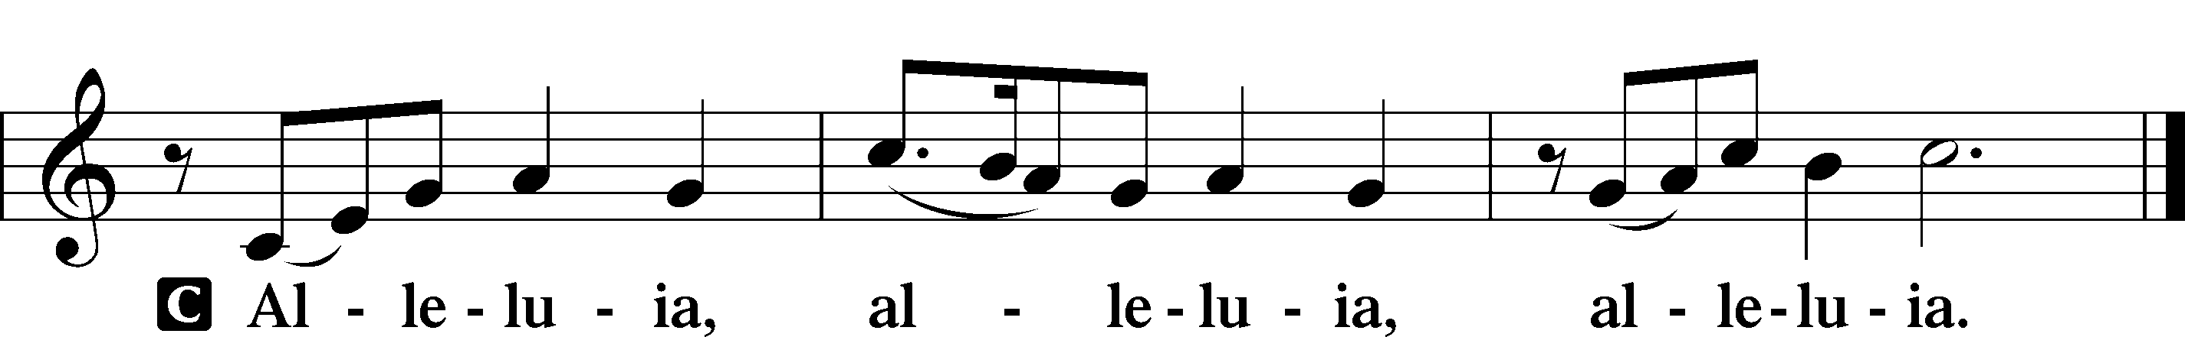

HOLY GOSPEL *Luke 8:26-39\**

P The Holy Gospel according to St. Luke, the eighth chapter.

C **Glory to You, O Lord.**

26Then they sailed to the country of the Gerasenes, which is opposite Galilee. 27When Jesus had stepped out on land, there met him a man from the city who had demons. For a long time he had worn no clothes, and he had not lived in a house but among the tombs. 28When he saw Jesus, he cried out and fell down before him and said with a loud voice, “What have you to do with me, Jesus, Son of the Most High God? I beg you, do not torment me.” 29For he had commanded the unclean spirit to come out of the man. (For many a time it had seized him. He was kept under guard and bound with chains and shackles, but he would break the bonds and be driven by the demon into the desert.) 30Jesus then asked him, “What is your name?” And he said, “Legion,” for many demons had entered him. 31And they begged him not to command them to depart into the abyss. 32Now a large herd of pigs was feeding there on the hillside, and they begged him to let them enter these. So he gave them permission. 33Then the demons came out of the man and entered the pigs, and the herd rushed down the steep bank into the lake and were drowned.

34When the herdsmen saw what had happened, they fled and told it in the city and in the country. 35Then people went out to see what had happened, and they came to Jesus and found the man from whom the demons had gone, sitting at the feet of Jesus, clothed and in his right mind, and they were afraid. 36And those who had seen it told them how the demon-possessed man had been healed. 37Then all the people of the surrounding country of the Gerasenes asked him to depart from them, for they were seized with great fear. So he got into the boat and returned. 38The man from whom the demons had gone begged that he might be with him, but Jesus sent him away, saying, 39“Return to your home, and declare how much God has done for you.” And he went away, proclaiming throughout the whole city how much Jesus had done for him.

P This is the Gospel of the Lord.

C **Praise to You, O Christ.**

**NICENE CREED**

**I believe in one God, the Father Almighty, maker of heaven and earth and of all things visible and invisible.**

**And in one Lord Jesus Christ, the only-begotten Son of God, begotten of His Father before all worlds, God of God, Light of Light, very God of very God, begotten, not made, being of one substance with the Father, by whom all things were made; who for us men and for our salvation came down from heaven and was incarnate by the Holy Spirit of the virgin Mary and was made man; and was crucified also for us under Pontius Pilate. He suffered and was buried. And the third day He rose again according to the Scriptures and ascended into heaven and sits at the right hand of the Father. And He will come again with glory to judge both the living and the dead, whose kingdom will have no end.**

**And I believe in the Holy Spirit, the Lord and Giver of life, who proceeds from the Father and the Son, who with the Father and the Son together is worshiped and glorified, who spoke by the prophets.**

**And I believe in one holy Christian and apostolic Church, I acknowledge one Baptism for the remission of sins, and I look for the resurrection of the dead and the life of the world to come. Amen.**

*Please be seated*

**ALL GOD’S CHILDREN – TALK**

**SERMON HYMN**

**Praise the One Who Breaks the Darkness** *LSB 849*

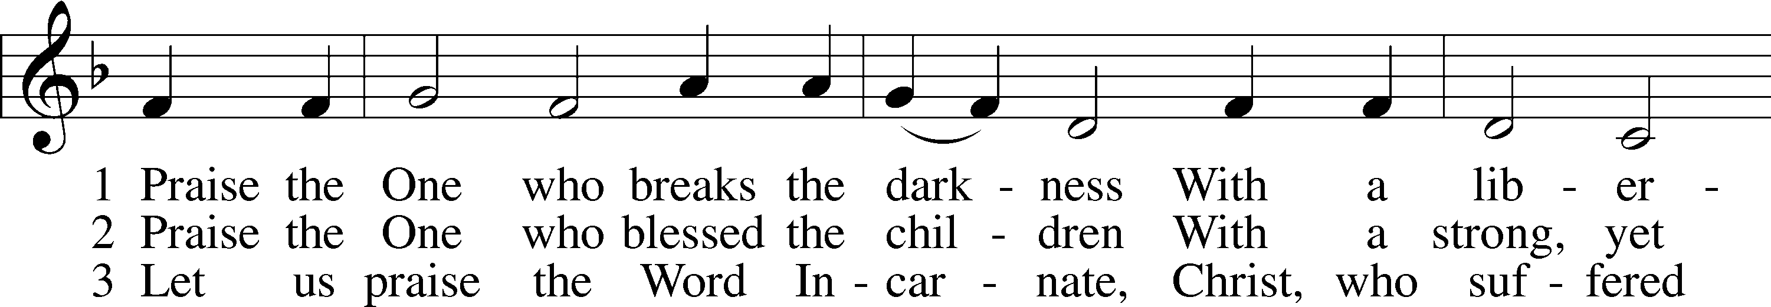

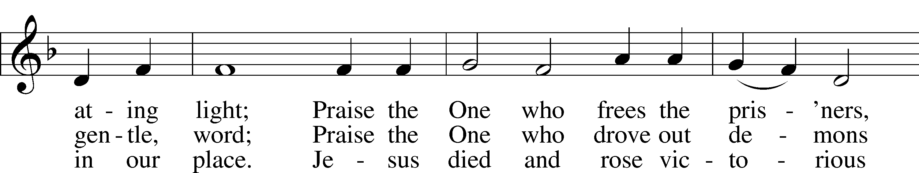

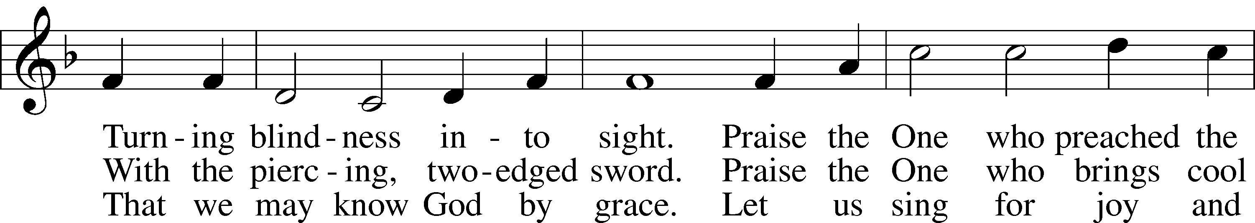

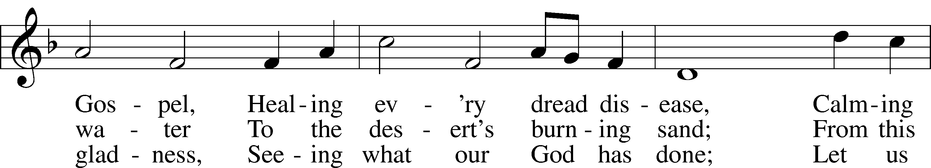

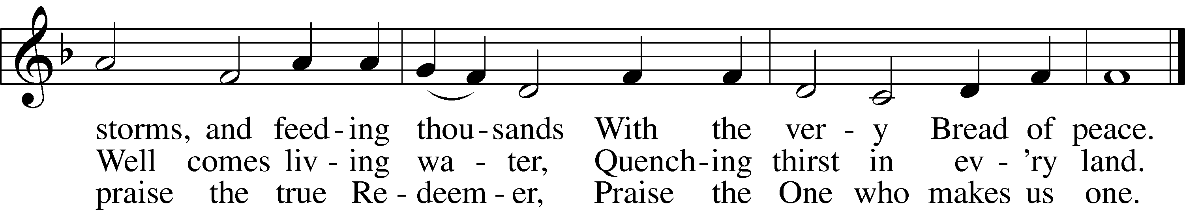

Text: Rusty Edwards, 1955

Tune: The Sacred Harp, 1844, Philadelphia

**SERMON**

PRAYER of the CHURCH

**After each Segment:**

P Lord, in Your Mercy,

**C Hear our Prayer.**

**After Final Segment:**

PHear us as we pray in His name and as He has taught us:

LORD’S PRAYER

C **Our Father who art in heaven,**

**hallowed be Thy name,**

**Thy kingdom come,**

**Thy will be done on earth**

**as it is in heaven;**

**give us this day our daily bread;**

**and forgive us our trespasses**

**as we forgive those**

**who trespass against us;**

**and lead us not into temptation,**

**but deliver us from evil.**

**For Thine is the kingdom**

**and the power and the glory**

**forever and ever. Amen.**

**SERVICE of the SACRAMENT**

*Please stand as able*

**PREFACE** *LSB 208*

P The Lord be with you.

C **And also with you.**

P Lift up your hearts.

C **We lift them to the Lord.**

P Let us give thanks to the Lord our God.

C **It is right to give Him thanks and praise.**

P It is truly good, right, and salutary that we should at all times and in all places give thanks to You, O Lord, holy Father, almighty and everlasting God, for the countless blessings You so freely bestow on us and all creation. Above all, we give thanks for Your boundless love shown to us when You sent Your only-begotten Son, Jesus Christ, into our flesh and laid on Him our sin, giving Him into death that we might not die eternally. Because He is now risen from the dead and lives and reigns to all eternity, all who believe in Him will overcome sin and death and will rise again to new life. Therefore with angels and archangels and with all the company of heaven we laud and magnify Your glorious name, evermore praising You and singing:

SANCTUS LSB 208

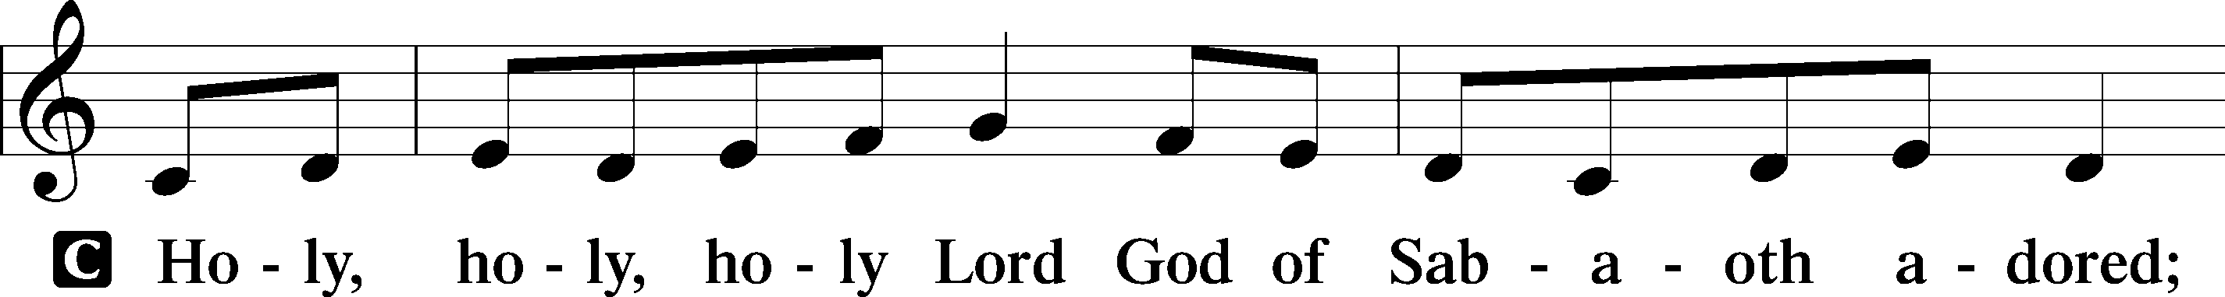

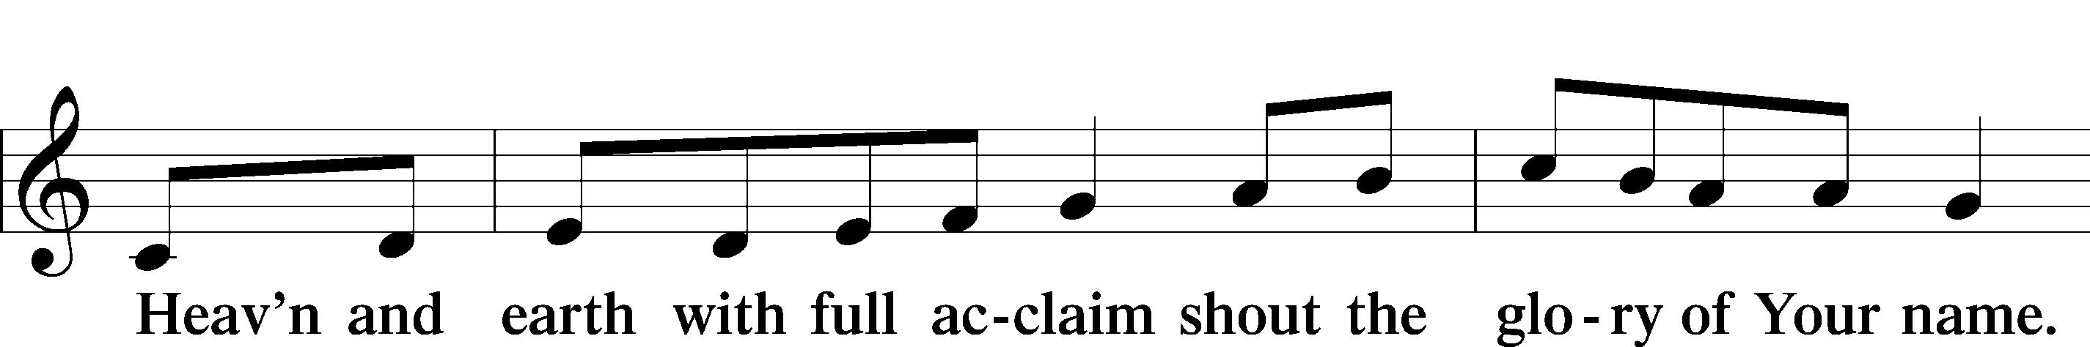

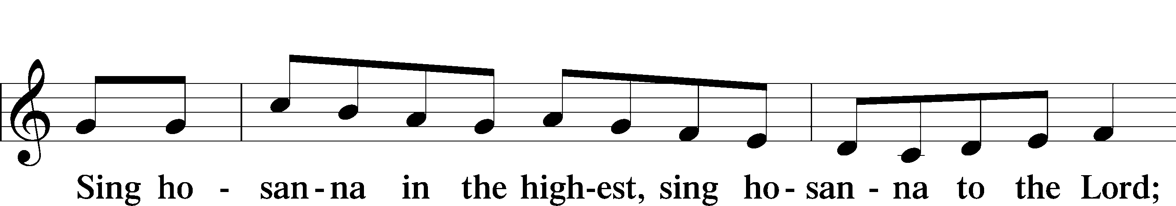

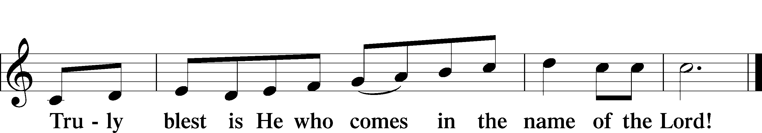

**THE WORDS OF OUR LORD**

P Our Lord Jesus Christ, on the night when He was betrayed, took bread, and when He had given thanks, He broke it and gave it to the disciples and said: “Take, eat; this is My T body, which is given for you. This do in remembrance of Me.”

In the same way also, He took the cup after supper, and when He had given thanks, He gave it to them, saying: “Drink of it, all of you; this cup is the New Testament in My T blood, which is shed for you for the forgiveness of sins. This do, as often as you drink it, in remembrance of Me.”

PAX DOMINI

P The peace of the Lord be with you always.

C **Amen.**

**AGNUS DEI**

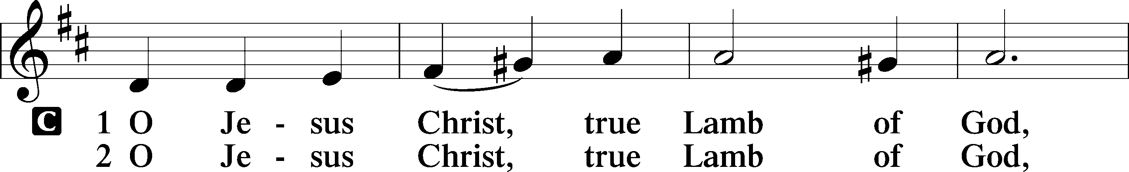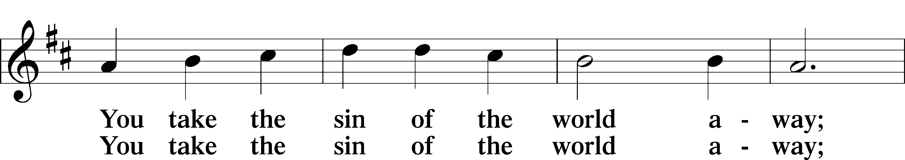

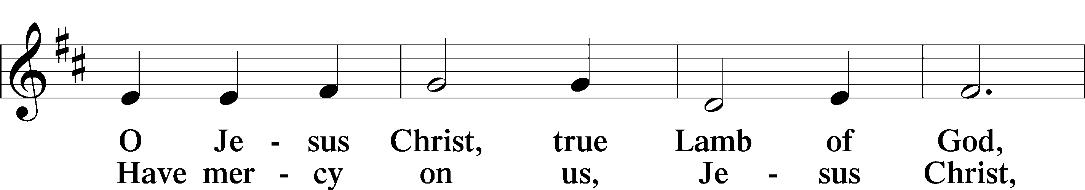

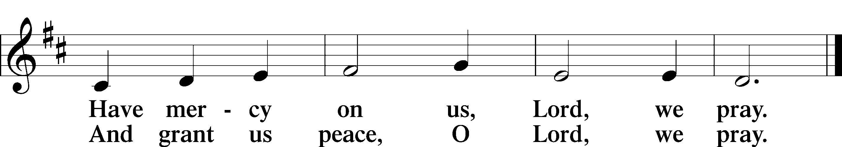

*Please be seated*

DISTRIBUTION

The pastor and those who assist him receive the body and blood of Christ first, then Communion will be served at the rail.. Ushers will help direct you forward via the center aisle; please return to your seats via the side aisles. Gluten-free bread is available for those who need it, as is non-alcoholic grape juice. Simply request either when you come forward to receive Communion.

**DISTRIBUTION HYMN**

**At the Lamb’s High Feast We Sing** *LSB 633 Please stand on v.8*

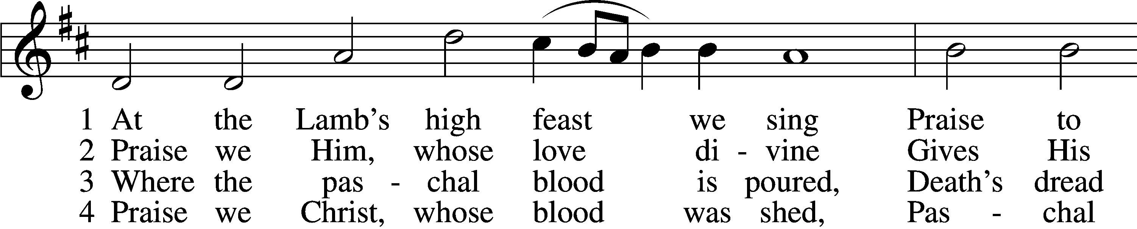

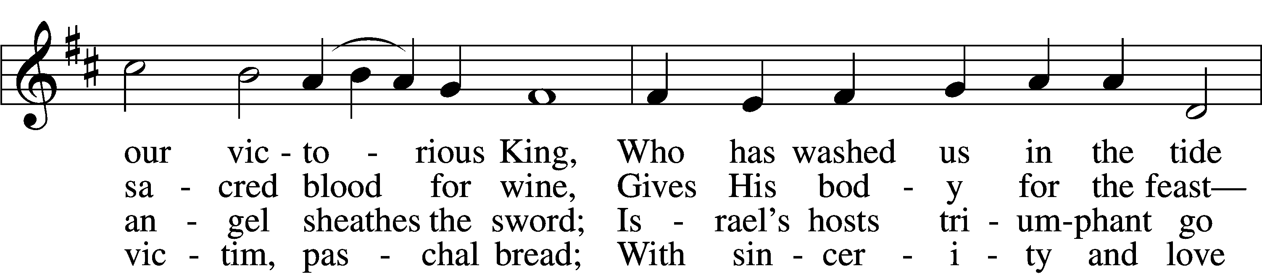

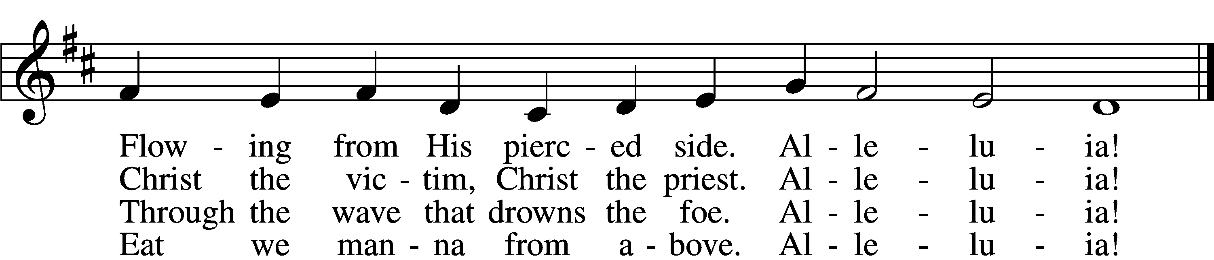

5 Mighty Victim from the sky,  
Hell’s fierce pow’rs beneath You lie;  
You have conquered in the fight,  
You have brought us life and light.  
    Alleluia!

6 Now no more can death appall,  
Now no more the grave enthrall;  
You have opened paradise,  
And Your saints in You shall rise.  
    Alleluia!

7 Easter triumph, Easter joy!  
This alone can sin destroy;  
From sin’s pow’r, Lord, set us free,  
Newborn souls in You to be.  
    Alleluia!

D 8 Father, who the crown shall give,  
Savior, by whose death we live,  
Spirit, guide through all our days:  
Three in One, Your name we praise.  
    Alleluia!

Text: Latin, c. 5th–10th cent.; tr. Robert Campbell, 1814–68, alt.  
Tune: Kirchengeseng, 1566, Ivancice  
Text and tune: Public domain

*Please stand as able*

**NUNC DIMITTIS** *LSB 211*

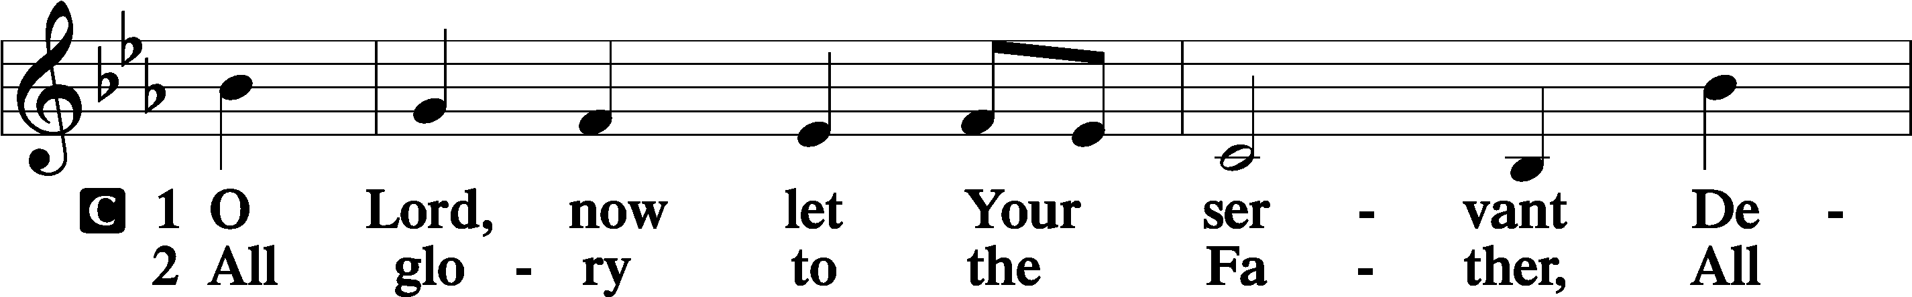

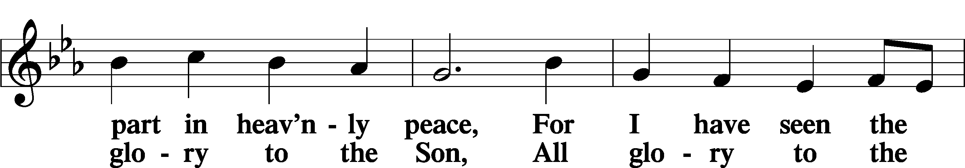

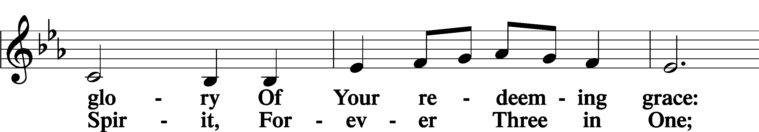

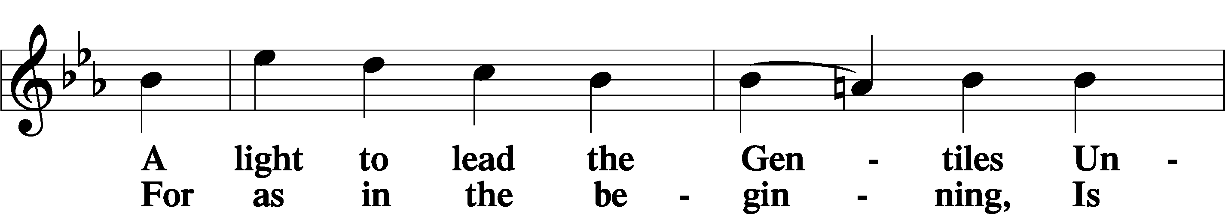

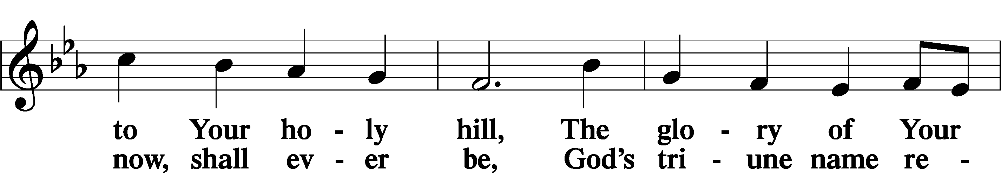

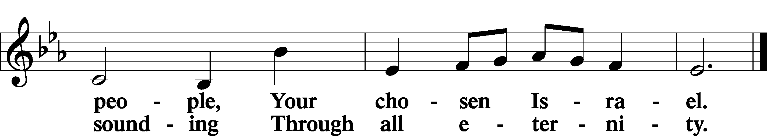

**POST COMMUNION COLLECT**

P Let us pray.

O God the Father, the fountain and source of all goodness, who in loving-kindness sent Your only-begotten Son into the flesh, we thank You that for His sake You have given us pardon and peace in this Sacrament, and we ask You not to forsake Your children but always to rule our hearts and minds by Your Holy Spirit that we may be enabled constantly to serve You; through Jesus Christ, Your Son, our Lord, who lives and reigns with You and the Holy Spirit, one God, now and forever.

C **Amen.**

**BENEDICAMUS**  LSB 212

P Let us bless the Lord.

C **Thanks be to God.**

BENEDICTION

P The Lord bless you and keep you.

The Lord make His face shine on you and be gracious to you.

The Lord look upon you with favor and T give you peace.

C **Amen.**

*Please be seated*

CLOSING HYMN

**All Hail the Power of Jesus’ Name** *LSB 549**sts. 4–7*

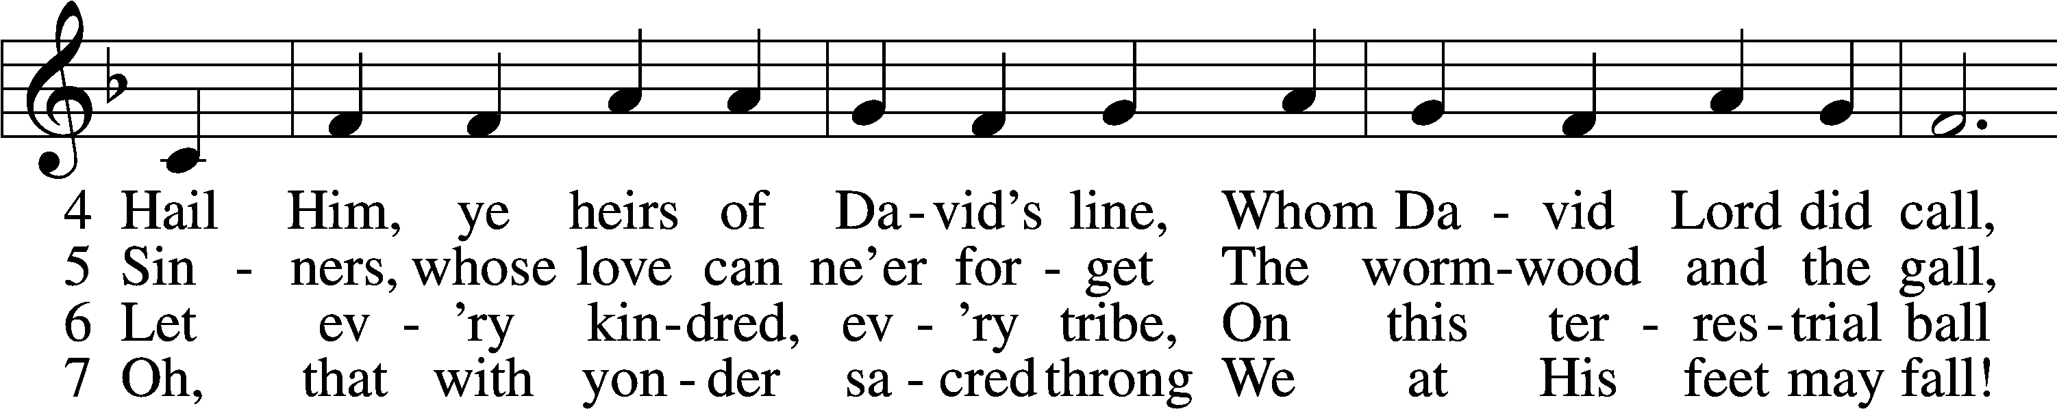

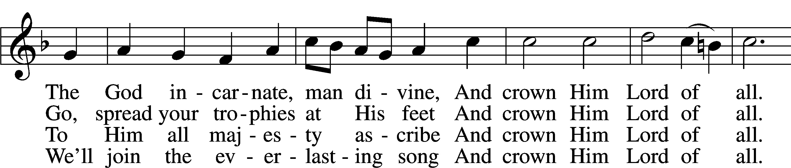

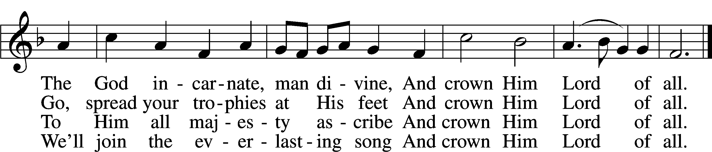

Text (sts. 4–5): Edward Perronet, 1726–92, alt.; (sts. 6–7): A Selection of Hymns, 1787, London, alt.

Tune: Oliver Holden, 1765–1844

Text and tune: Public domain

**ANNOUNCEMENTS and SENDING WORDS**

P We go to live for Jesus!

**C We go to share His love!**

Acknowledgments

Unless otherwise indicated, Scripture quotations are from the ESV® Bible (The Holy Bible, English Standard Version®), copyright © 2001 by Crossway, a publishing ministry of Good News Publishers. Used by permission. All rights reserved. Created by Lutheran Service Builde

# **SERVING in GODS HOUSE TODAY**

Pastor: Rev. Paul Schneider

Elder: Ken Mertz

Ushers: Bill & Terry Stiles

Greeters: Brian & Tami Techel

Coffee Bob & Kathy Erat

Counters: Ric Francis, Sharon Kwapis

Altar Care: Kathy Erat

Virtual Organist: Bob Erat

Children’s Talk: Nancy Ely

**PRAYERS**

*Please contact the office with updates to the prayer list. People will remain on the prayer list for* ***4 weeks*** *before being removed. If they need to remain on the list, please keep Elaine informed and of any updates. This will help us to have a more accurate list. Thanks for your cooperation.*

**Those who continue to grieve the passing of loved ones**, the family of Ruth Luebs.

**Those with upcoming surgery**:

**Those recovering from surgery:**  Tanner Beyers, Sasha (Rose Dittmans Grandson), Jennifer Martin, Ron Kwapis, Marge Kunish, Velma Ward.

**Those with health concerns:** Tiffany Amsdill**,** Laurie Breen, Hope Buchinger, Betsy Cook Kay, Gregg, Hilda Koch, Eleanor Raether, Beth Smith, Judi Stutzman, and Joann Whitney.

**Those diagnosed with cancer**: Leah Eicher, Rachel Frisch, Joe Gibson, Janice Knoellinger, Leslie Martin, Brian Morgan, Hope Osantowski,, and John Stutzman.

**Those under Hospice Home Care:**  Ken Williamson, Jim (Joann Whitney’s brother-in-law).

**BIRTHDAYS: ANNIVERSARIES;**

6/19 Janice Knoellinger 6/21 Sterling & Jeanine Boldery

6/19 Terri Raithel 6/22 Dave & Brittany Beyers

6/11 Sophia Temble 6/22 Gene & Jean Seibel

6/25 Jim Bernthal 6/22 Amber & Roger Bommarito

**MESSAGES**

**ALTAR FLOWERS this** week were given to the Glory of God by the Stutzmans in

celebration of their anniversary.

**OUTREACH PICNIC COMMITTEE MEETING:** We are starting up again If you are interested in being part of this committee please sign up on the sheet on the board in the narthex. We will be needing a few grills, cooks, Help setting up tents & tables and chairs, Help with stocking the coolers with ice, water and beverages. The church picnic is on July 24th after the church service. Kathy Erat will be putting our games together. We will be supplying the meats hotdogs, hamburgers, buns, condiments, and utensils for the food and eating. and beverages. We do ask that you bring a dish to pass if you can. A salad or dessert.

**MEMBER & GUEST CARDS:** If you have not filled out a member/guest card, please take the time to fill one out and place it in the plate behind the back pews in our sanctuary**.**

**LWML SUMMER POP-UP CRAFT SALES:** LWML plans to have occasional mini craft sales this summer. With short notice we will set up a few canopies in the front yard and offer our crafts for sale, with the profits designated for missions, both locally and throughout the world. Dates have yet to be determined. So, crafters, please get thinking about what handmade items you can prepare in advance for us to sell. We welcome and appreciate your donations.

**CANCER & FRIENDS SUPPORT GROUP:** Meetings are the 4th Tuesday of each month at 5:30pm on June 27th. This month’s meeting is in Trinity Lutheran Church fellowship hall. Our meetings are for everyone. It is for cancer patients, spouse, care-givers, and loved ones. We all have special needs when it comes to cancer. Cancer is hard for everyone involved not just the patient. You need to understand what the patient is going through and the cancer patient has to understand what everyone else is going through. It not easy for anyone. That is why we bring in different guest speakers. We are here for that helping hand you may need. Our guest speaker of this month is Dona Wishart from OCCOA. Dona comes with a wealth of information about OCCOA, how they can help us and what they have to offer us. For more information you can contact Elaine by email [elaineraschke@gmail.com](mailto:elaineraschke@gmail.com) or text to 989-350-4391.

*We will be moving some of the* ***mail boxes*** *around soon. We will keep you up to date on the day it will take place. Roger*

**LARGE PRINT BULLETINS**: We now have large print bulletins, if you would like one please see one of the ushers.

**PORTALS OF PRAYER** *for July-September are in and on the shelf in the narthex.*

**THIS WEEK AT TRINITY**

***June 19 Sunday***

9:00 am Worship Service

10:00 am Fellowship & Coffee Hour

***June 20 Monday***

**NEWSLETTER DEADLINE**

***June 21 Tuesday***

***June 22*** ***Wednesday***

***June 23 Thursday***

***June 24 Friday***

***June 25 Saturday***

10:00 am Ruth Luebs Memorial

***June 26 Sunday***

9:00 am Worship Service

10:00 am Fellowship & Coffee Hour

**SERVING IN GOD’S HOUSE NEXT WEEK 6/26/2022**

Pastor: Rev. Paul Schneider

Elder: Glen Smith

Ushers: Mike Goodrich, Roxie Mohr

Greeters: Bob & Kathy Erat

Coffee Servers:

Counters: Kathy Erat, Donna Cottrell

Altar Care: Judi Stutzman

Virtual Organist: Bob Erat

Children’s Talk: Nancy Ely

Post Service Bible Study: Tom Beach



